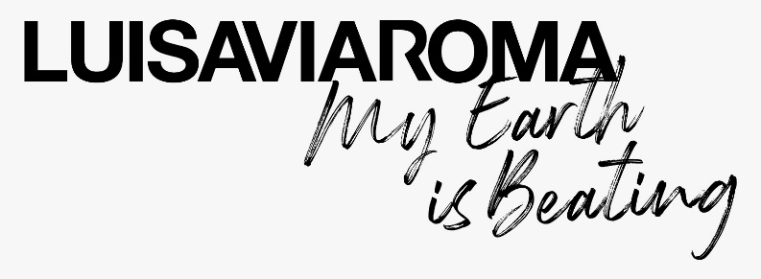
A Photo-Collection for Climate
by LuisaViaRoma
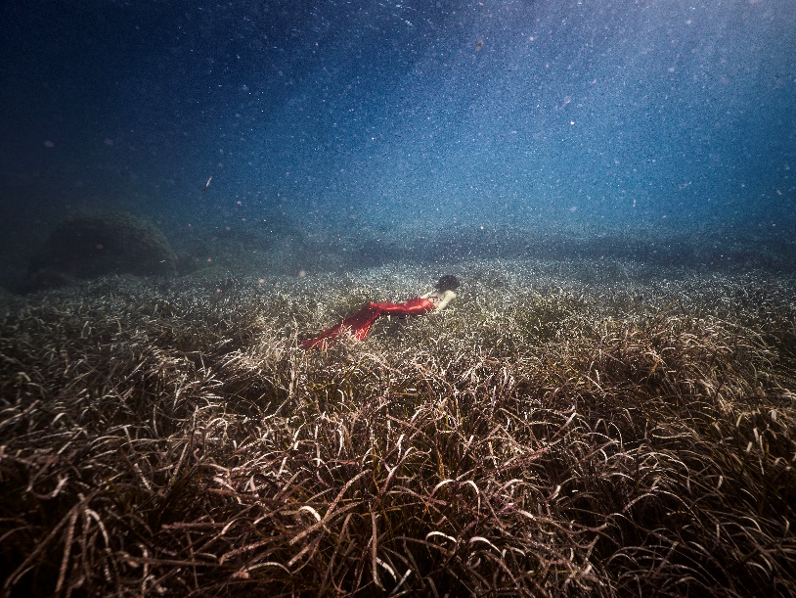
@luisaviaroma
@extremeelive
#myEIB
#LVRSustainable

THE END OF THE APNEA
Have you ever asked yourself what a hectare of Acacia nilotica replanted in the Saudi Arabian desert can achieve? Or a hectare of Posidonia oceanica on the seafloor of a natural reserve in Sardinia? And do you know what a hectare of mangroves on the central Senegalese coastline can accomplish?

This is what they can do: protect, look after, strengthen, nourish, hide, create, stretch the arms and block microplastics that would otherwise end up unrelentingly in the food chain, as well as capturing the carbon dioxide that decades of industrialization has released into the atmosphere, causing nature a long and dangerous period of apnea.
All over the world, an alliance is forming between scientists, entrepreneurs, visionaries, activists, journalists and photographers who are convinced that climate change can be fought via the union of two ingenious minds: that of humankind, who is developing new zero-impact technologies (electric vehicles for example) , and that of nature, which brings with it all the patents necessary to turn back the hands of the clock and return the earth to its original state.
Included in this international movement is Extreme E (the championship that brings together the spectacles of both sport and nature), My Earth Is Beating by LUISAVIAROMA and LVRSustainable (the fight against climate change becomes photographic art, a story and a crystal clear wake-up call).
The first, a revolutionary series of electric SUV off-road races in the most extreme environments on the planet, from Greenland to the millenary valleys of AIUla, accompanied by a series of concrete actions initiated by local NGOs working to safeguard the ecosystem.

The second, a project documenting climate change and the solutions to counter it, through a language that balances art, photography, storytelling and investigative journalism.

Five trips.
Five collections of iconic photos.
Dozens of unedited stories.

The words of reporter Raffaele Panizza. Photos by World Press Photo winners Luca Locatelli and Gabriele Galimberti both of whom are among the most followed contributors to National Geographic. The propulsive force of LUISAVIAROMA, one of the world’s leading online retailers for luxury fashion and Official Fashion Partner to Extreme E.
United to transform My Earth Is Beating #myEIB into an art gallery of exceptional images released one by one to the media and influences around the world, who in each country are free to replicate, repost, comment upon and publish, in an immense and unedited experiment of citizen journalism. The National Geographic Instagram profile, which has almost 200 million followers, has relaunched the stories told by My Earth Is Beating on different occasions.
- The first stop, which took place in Saudi Arabia, focused on the future and desertification.
- The second, in Central Senegal, followed the mangrove reforestation projects, an intelligent biome capable of locking down the landscape and blocking the rising sea level.
- The third, in Greenland, told the stories of the Inua, the superheroes of the climate.
- The fourth, in Sardinia, among forest fires, solutions and immersions into the groves of Posidonia Oceanica known as the Amazon of the Mediterranean.
- The final stop will be in England, from the 13th to the 19th of December, between London and Dorset, following the rewilding projects taking place in the city and the countryside: from foxes, beavers and bison reintroduced to their natural environments, experiencing a safari will soon be possible in Europe.
All the photos and all the stories are available here
- MEDIA KIT with the first four editions: https://we.tl/t-qGt0dE0Yz8
- Landing page LVR: https://www.luisaviaroma.com/en-it/landing/extreme-e-partnership
- Social Movement #myEIB: https://www.instagram.com/explore/tags/myeib/

“At each stage, Locatelli, Galimberti and Panizza will make available to the press- and then to the collective knowledge- a selection of stories and the most beautiful and decisive photos” says Andrea Panconesi, president of LuisaViaRoma, “which at the end of this great odyssey of awareness will be further enhanced on the occasion of an international exhibition in Florence, the city where LuisaViaRoma has its headquarters: cradle of the Renaissance and not coincidentally, also of this new climate renaissance to which we are all called to make a contribution”
“My Earth Is Beating represents an important occasion to introduce the Nature based Solutions to the world” say Luca Locatelli and Raffaele Panizza, the artistic director and editorial director of the project, “if man helps nature take back spaces which were once its own, nature will be able to save itself. And as a consequence, all of us”.

About Extreme E:
Extreme E is a radical new racing series, sees electric SUVs compete in extreme environments around the world which have already been damaged or affected by climate and environmental issues. The five-race global voyage highlights the impact of climate change and human interference in some of the world’s most remote locations and promotes the adoption of electric vehicles in the quest for a lower carbon future for the planet.

To minimise local impact, Extreme E races will not be open to spectators, with fans instead invited to follow the action through live TV broadcast, and on social media.

The St. Helena, a former passenger cargo ship, has undergone a multi-million Euro refit to minimise emissions and transform her into Extreme E’s operations hub. The ship will be used to transport the championship’s freight and infrastructure, including vehicles, to the nearest port, minimising Extreme E’s footprint, as well as being used to facilitate scientific research through its on-board laboratory.
Extreme E is also pioneering hydrogen fuel cell technology which will enable its race fleet to be charged using zero emission energy. This innovative solution from AFC Energy uses water and sun to generate hydrogen power. Not only will this process emit no greenhouse emissions, its only by-product will be water, which will be utilised elsewhere on-site.

About LUISAVIAROMA and LVR Sustainable
Defined by the Financial Times as “A haven for directional fashion,” LUISAVIAROMA.COM is the top online luxury fashion destination with 5,000,000 visitors per month and worldwide shipping.
LuisaViaRoma is one of the world’s leading online retailers for luxury fashion. Founded in 1929 by the Panconesi family as a small boutique in Via Roma in Florence, at the beginning of 2000s the company became the first online fashion platform with its launch of LUISAVIAROMA.COM, combining a curated brick-and-mortar with a digital presence. In its headquarters in Florence, LuisaViaRoma has approximately 230 employees and ships to over 120 countries globally, with a reported revenue of approximately €180 million in 2020, of which over 90% was online and over 75% shipped to international customers. LuisaViaRoma prides itself on offering the best choice of menswear, womenswear, childrenswear, home, beauty and a special section dedicated to street style and sportswear collections from more than 600 international top brands including Gucci, Balenciaga, Moncler, Valentino and more.
Over time, the company has developed a strong marketing strategy driven by a philanthropic approach and culture of sustainability. LVRSustainable is the dedicated section to sustainability which offers a careful selection of brands and special collaborations with non-profit entities for the benefit of social causes, focussing on sustainability, promoting eco-conscious fashion and special projects with a positive impact on the world, preserving the environment and protecting the planet.

